AGENDA FOR THE LOUISIANA USED MOTOR VEHICLE COMMISSION
Derek L. Parnell
Executive Director
John Bel Edwards
Governor

3132 Valley Creek Drive, Baton Rouge, LA 70808
Toll Free 1-800-256-2977 • Phone 225-925-3870 • Fax 225-925-3869
www.lumvc.louisiana.gov
Used Motor Vehicle Commission
State of Louisiana
Office of the Governor

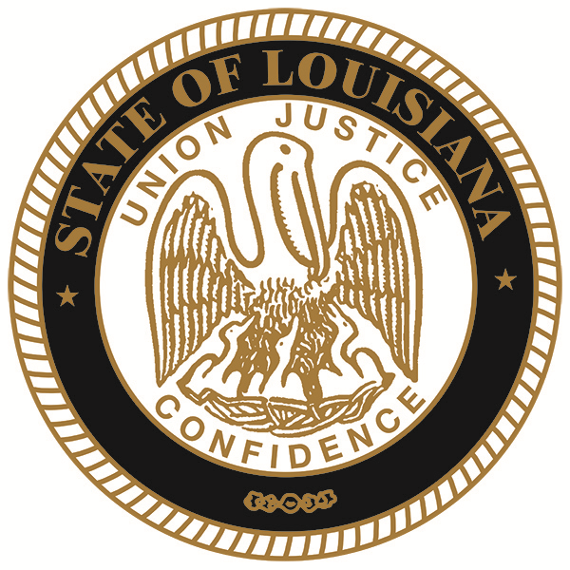

REGULAR MEETING

DATE: October 17, 2016

TIME: 9:30 a.m.

PLACE: Louisiana Used Motor Vehicle Commission
3132 Valley Creek Drive
Baton Rouge, LA 70808

- CALL TO ORDER

- PLEDGE OF ALLEGIANCE

- ROLL CALL

- PUBLIC COMMENTS

- ADOPTION AND APPROVAL OF MINUTES – July 2016

- ITEMS FOR DISCUSSION AND ACTION

- Review of Financial Report
- Review of Legislative Audit Report (F/Y July 01, 2015 – June 30, 2016)
  - Mr. John McKowen, CPA
- Review of Financial Report – September 2016

- Ratification of Imposed Penalties

- Case #2016-105 Expert Auto Sales & Service, LLC – (13503 Florida Blvd., Baton Rouge, LA 70819) UD.239518
- Case #2016-421 Maximus Motorcars – (4438 Pontchartrain Drive, Slidell, LA 70458) UD.244673
- Case #2016-444 Nuba Sales – (9499 Highway 182, Opelousas, LA 70570) UD.239260

- Ratification of Revocations
1. Guerrero’s Auto Sales – (306 Pecan Grove Road, Scott, LA 70583) UD.244425
2. Country Equipment & Salvage Co. – (1352 Highway 29 East, Bunkie, LA 71322) AD.40476
3. Bayou Scrap and Recycling, LLC – (603 Front Street, Winnfield, LA 71483) AD.40628
4. Tony’s Auto Sales – (2935 Cameron Street, Lafayette, LA 70506) UD.424950
5. Auto Max of Alexandria, Inc. – (104 Bolton Avenue, Alexandria, LA 71301) UD.239293
6. Delta Auto Wholesalers – (2415 Tyler Street, Kenner, LA 70062) UD.239427
7. Havens P.O.V. – (7822 Highway 190 West, Merryville, LA 70653) UD.240553
8. Derrin’s Auto Wholesale, LLC – (78011 Highway 25, Folsom, LA 70437) UD.243184
9. George’s Junk Cars – (3501 Highway 165 South, Monroe, LA 71202) AD.40500
10. Elite Auto Sales, LLC – (3011 East Highway 90, New Iberia, LA 70560) UD.244345
11. Royal Auto Sales, Inc. – (315 Macon Road, #B, Lafayette, LA 70506) UD.242344
12. Southwest Auto Sales and Salvage, Inc. – (868 South Cooley Road, Dequincy, LA 70633 UD.243801 and AD.040776
13. Murph’s Auto Sales – (120207 Mammoth Avenue, Baton Rouge, LA 70814) UD.240319

VIII. EXECUTIVE DIRECTOR’S REPORT

- Review of Compliance Investigation and Complaint Totals

IX. ITEMS FOR NEXT AGENDA – November 21, 2016

X. ADJOURNMENT

*Agenda shall be provided to all Commissioners and all employees and contractors of the Commission.

Posted by____________________________________ Date: __________________ Time: __________

